

FYP Management Platform

Task 1: Requirements Elicitation & Documentation
Course | Software Design and Analysis
Scenario | FYP Platform for Final Year Students
Group Members | Aazan Noor (24P-0706) | Munesh Kumar (24P-0635) | Ahmed Asim (24P-0740)
Section | BS-CS-4C
University | FAST-NUCES, Peshawar Campus
Assignment | Task-2

Table of Contents:
Table of Contents: 2
1. Requirement Elicitation 3
1.1 Stakeholders 3
1.2 Elicitation Strategy 3
1.3 Problems Analyzed 3
2. Requirements: 4
2.1 Functional Requiremets: 4
2.2 Non-Functional Requirements: 5
4. Use Case Diagram 6
5. Use Case Specifications 7
UC-01: Submit FYP Proposal 7
UC-02: Send Supervision Request 7
UC-03: Upload Project Document 8
UC-04: Submit Peer Review 8
Task 2: UML Diagrams: 9
Work Distribution: 9
6. UML Class Diagram: 9
7. UML Sequence Diagrams: 10
8. UML Activity Diagrams: 11
9. State Machine Diagrams: 15

1. Requirement Elicitation

1.1 Stakeholders
The primary stakeholders for this system are the final-year (senior) students, as they are most directly affected by the FYP process. Secondary stakeholders are project supervisors and the FYP Coordinator.

1.2 Elicitation Strategy
Requirements were gathered through informal discussions with senior students by going to their hostels and then having an in-depth discussion about FYP issues to understand their actual needs. To avoid gold plating (adding features that no stakeholder asked for), we focused strictly on solving real, reported problems. The elicited requirements were then separated into functional requirements and non-functional requirements. This is how we analyzed them during the process.

1.3 Problems Analyzed
The following problems came up consistently across discussions with senior students and then going through some research online based on Reddit reviews and articles through review of the existing process:
- Students pick topics without knowing if the same project was done before.
- Supervisors sometimes become unreachable after the initial assignment.
- Group contribution is uneven, with no way to measure individual effort.
- Progress is not tracked regularly, leading to last-minute failures.
- Students have no formal way to report a concern with their supervisor.

2. Requirements:

2.1 Functional Requiremets:
FR-01 | Users log in and see a dashboard specific to their role: student, supervisor, or admin. No user can access another role's data or features.
FR-02 | Students add their technical skills to their profile. Supervisors add their research areas. This information is visible to both sides before a supervision request is made.
FR-03 | Each supervisor's profile shows their average response time to student submissions. Students can view this before choosing a supervisor.
FR-04 | Students form a project group of up to three members. Each member is linked to the shared project, and individual contributions are logged separately.
FR-05 | Students can post a listing to find group members with specific skills they need for their project.
FR-06 | Supervisors can post project ideas to an Idea B  ank. Students who do not yet have a topic can browse and select an idea from this bank.
FR-07 | Groups submit their project title, domain, and proposal details for supervisor review.
FR-08 | When a proposal is submitted, the system checks whether the same title or a very similar project already exists in the archive. If a match is found, the submission is blocked and the student is shown a message explaining why.
FR-09 | Groups send a formal supervision request to a specific teacher through the system.
FR-10 | Supervisors accept or decline supervision requests and must provide a written reason for any rejection.
FR-11 | supervisors
FR-12 | Supervisors define deadlines for major project phases such as the mid-defense and final submission. These deadlines are visible to all group members.
FR-13 | Students upload project files at any stage of the project. The system keeps a record of all previous versions so that earlier files can still be retrieved.
FR-14 | Students submit a short weekly update log describing what they worked on.
FR-15 | Supervisors write feedback on uploaded files and weekly logs. Feedback is saved with the date and time it was written.
FR-16 | If a group has not submitted any progress log within a period defined by the coordinator, the system automatically sends an alert to both the group and their supervisor.
FR-17 | Group members submit private peer reviews rating each other's individual contributions. These ratings are kept hidden from other group members. Only the supervisor and admin can view the aggregated results.
FR-18 | Supervisors enter final marks through the system using a grading rubric. The rubric criteria are visible to students from the beginning of the semester.
FR-19 | Completed projects are saved in a searchable archive so that junior students can browse them as examples of past work.
FR-20 | Students can submit a formal complaint to the admin if their supervisor is unresponsive or they have an unresolved issue.

2.2 Non-Functional Requirements:
NFR-01 | Performance | Dashboard pages must load within an acceptable time under normal usage. This threshold will be agreed upon with the IT department during the design phase.
NFR-02 | Security | Passwords must be stored using a secure hashing method. Student grades and peer review scores must only be visible to users with the appropriate role.
NFR-03 | Reliability | The system must remain operational throughout the active academic year, especially during high-traffic periods such as the final submission week.
NFR-04 | Robustness | In the event of a server failure, uploaded project files must be recoverable up to the most recent backup point.
NFR-05 | Usability | A new student must be able to complete the proposal submission process on their first login without needing a tutorial or external help.
NFR-06 | Compatibility | The system must work correctly on current versions of Chrome and Firefox and must be usable on standard mobile screen sizes.
NFR-07 | Scalability | The system must support all registered final-year students and supervisors using it at the same time without any slowdown.
NFR-08 | Maintainability | The code must follow a modular structure so that a developer familiar with the codebase can locate and fix a defect in a reasonable amount of time.
NFR-09 | Privacy | Peer review ratings submitted by group members must be completely hidden from all other group members. Only the supervisor and admin can view the aggregated results.
NFR-10 | Accessibility | Text and background colors must have sufficient contrast so that students with low vision can read the interface without difficulty.

4. Use Case Diagram
The use case diagram below illustrates the system boundary, the three primary actors (student, supervisor, and admin/FYP coordinator), and all core use case interactions, including include and extend relationships.
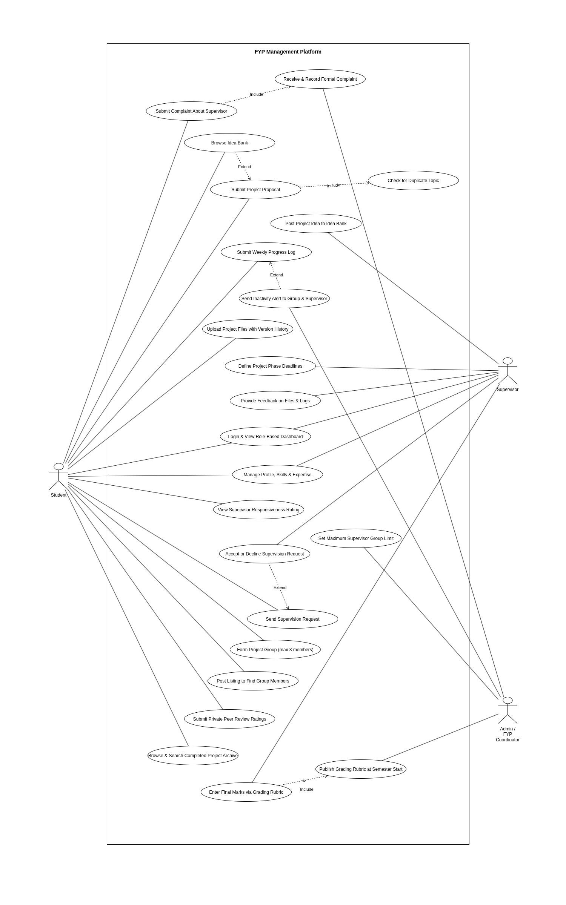
Figure 1: UML Use Case Diagram

5. Use Case Specifications
The following tables describe the core use cases in detail following the standard IBM tabular format.

UC-01: Submit FYP Proposal
Use Case # | UC-01
Name | Submit FYP Proposal
Brief Description | Student submits a new project proposal including title, domain, and abstract for approval.
Actor | Student (Primary Actor)
Precondition | The student is logged in and belongs to a formed project group.
Basic Flow | 1. The student enters the project title, domain, and abstract.  2. The student clicks Submit.  3. System checks for a duplicate title «include».  4. The proposal is saved and marked as Pending Review.
Alternate Flow | 3a. A matching title is found → System blocks submission and asks student to revise the title.
Special Requirements | The duplicate check algorithm must respond in under 2 seconds.
Postcondition | The proposal is stored with the status Pending Review. The supervisor is notified.

UC-02: Send Supervision Request
Use Case # | UC-02
Name | Send Supervision Request
Actor | Student (Primary), Supervisor (Secondary)
Precondition | The student is logged in, a proposal has been submitted, and the chosen supervisor has not reached their group limit.
Basic Flow | 1. The student browses supervisor profiles and selects one.  2. The student sends a supervision request.  3. The supervisor receives a notification and accepts.  4. The system links the group to the supervisor.
Alternate Flow | 3a. Supervisor rejects with written reason → Student notified, can request another supervisor.  3b. No response within the coordinator-defined period → Admin is alerted to assign manually.
Postcondition | The group is assigned to a supervisor. The relationship is recorded in the system.

UC-03: Upload Project Document
Use Case # | UC-03
Name | Upload Project Document
Actor | Student (Primary Actor)
Precondition | The student is logged in and has an active, supervisor-approved project.
Basic Flow | 1. The student navigates to the Documents section.  2. The student selects a file and adds a brief description.  3. The system saves the file and assigns a version number.  4. The supervisor receives a notification of the new upload.
Alternate Flow | 3a. File type is not supported → System rejects upload and tells student which types are accepted.
Postcondition | Document stored with the supervisor. The supervisor can now view and comment.

UC-04: Submit Peer Review
Use Case # | UC-04
Name | Submit Peer Review
Actor | Student (Primary Actor)
Precondition | The student is logged in, and the peer review window has been opened by the coordinator.
Basic Flow | 1. The student opens the peer review form.  2. The student rates each group member using the provided rubric.  3. The student submits the completed form.  4. The system saves ratings as private and confirms submission.
Alternate Flow | 3a. Form is incomplete → System highlights missing fields and prevents submission.
Postcondition | Ratings saved privately. Not visible to other group members. Supervisors and admins can view aggregated results.

Task 2: UML Diagrams:

Work Distribution:
Aazan Noor (24P-0706) | Class Diagram and Sequence Diagram
Munesh Kumar (24P-0635) | Activity Diagram
Ahmed Asim (24P-0740) | State Machine Diagram

6. UML Class Diagram:
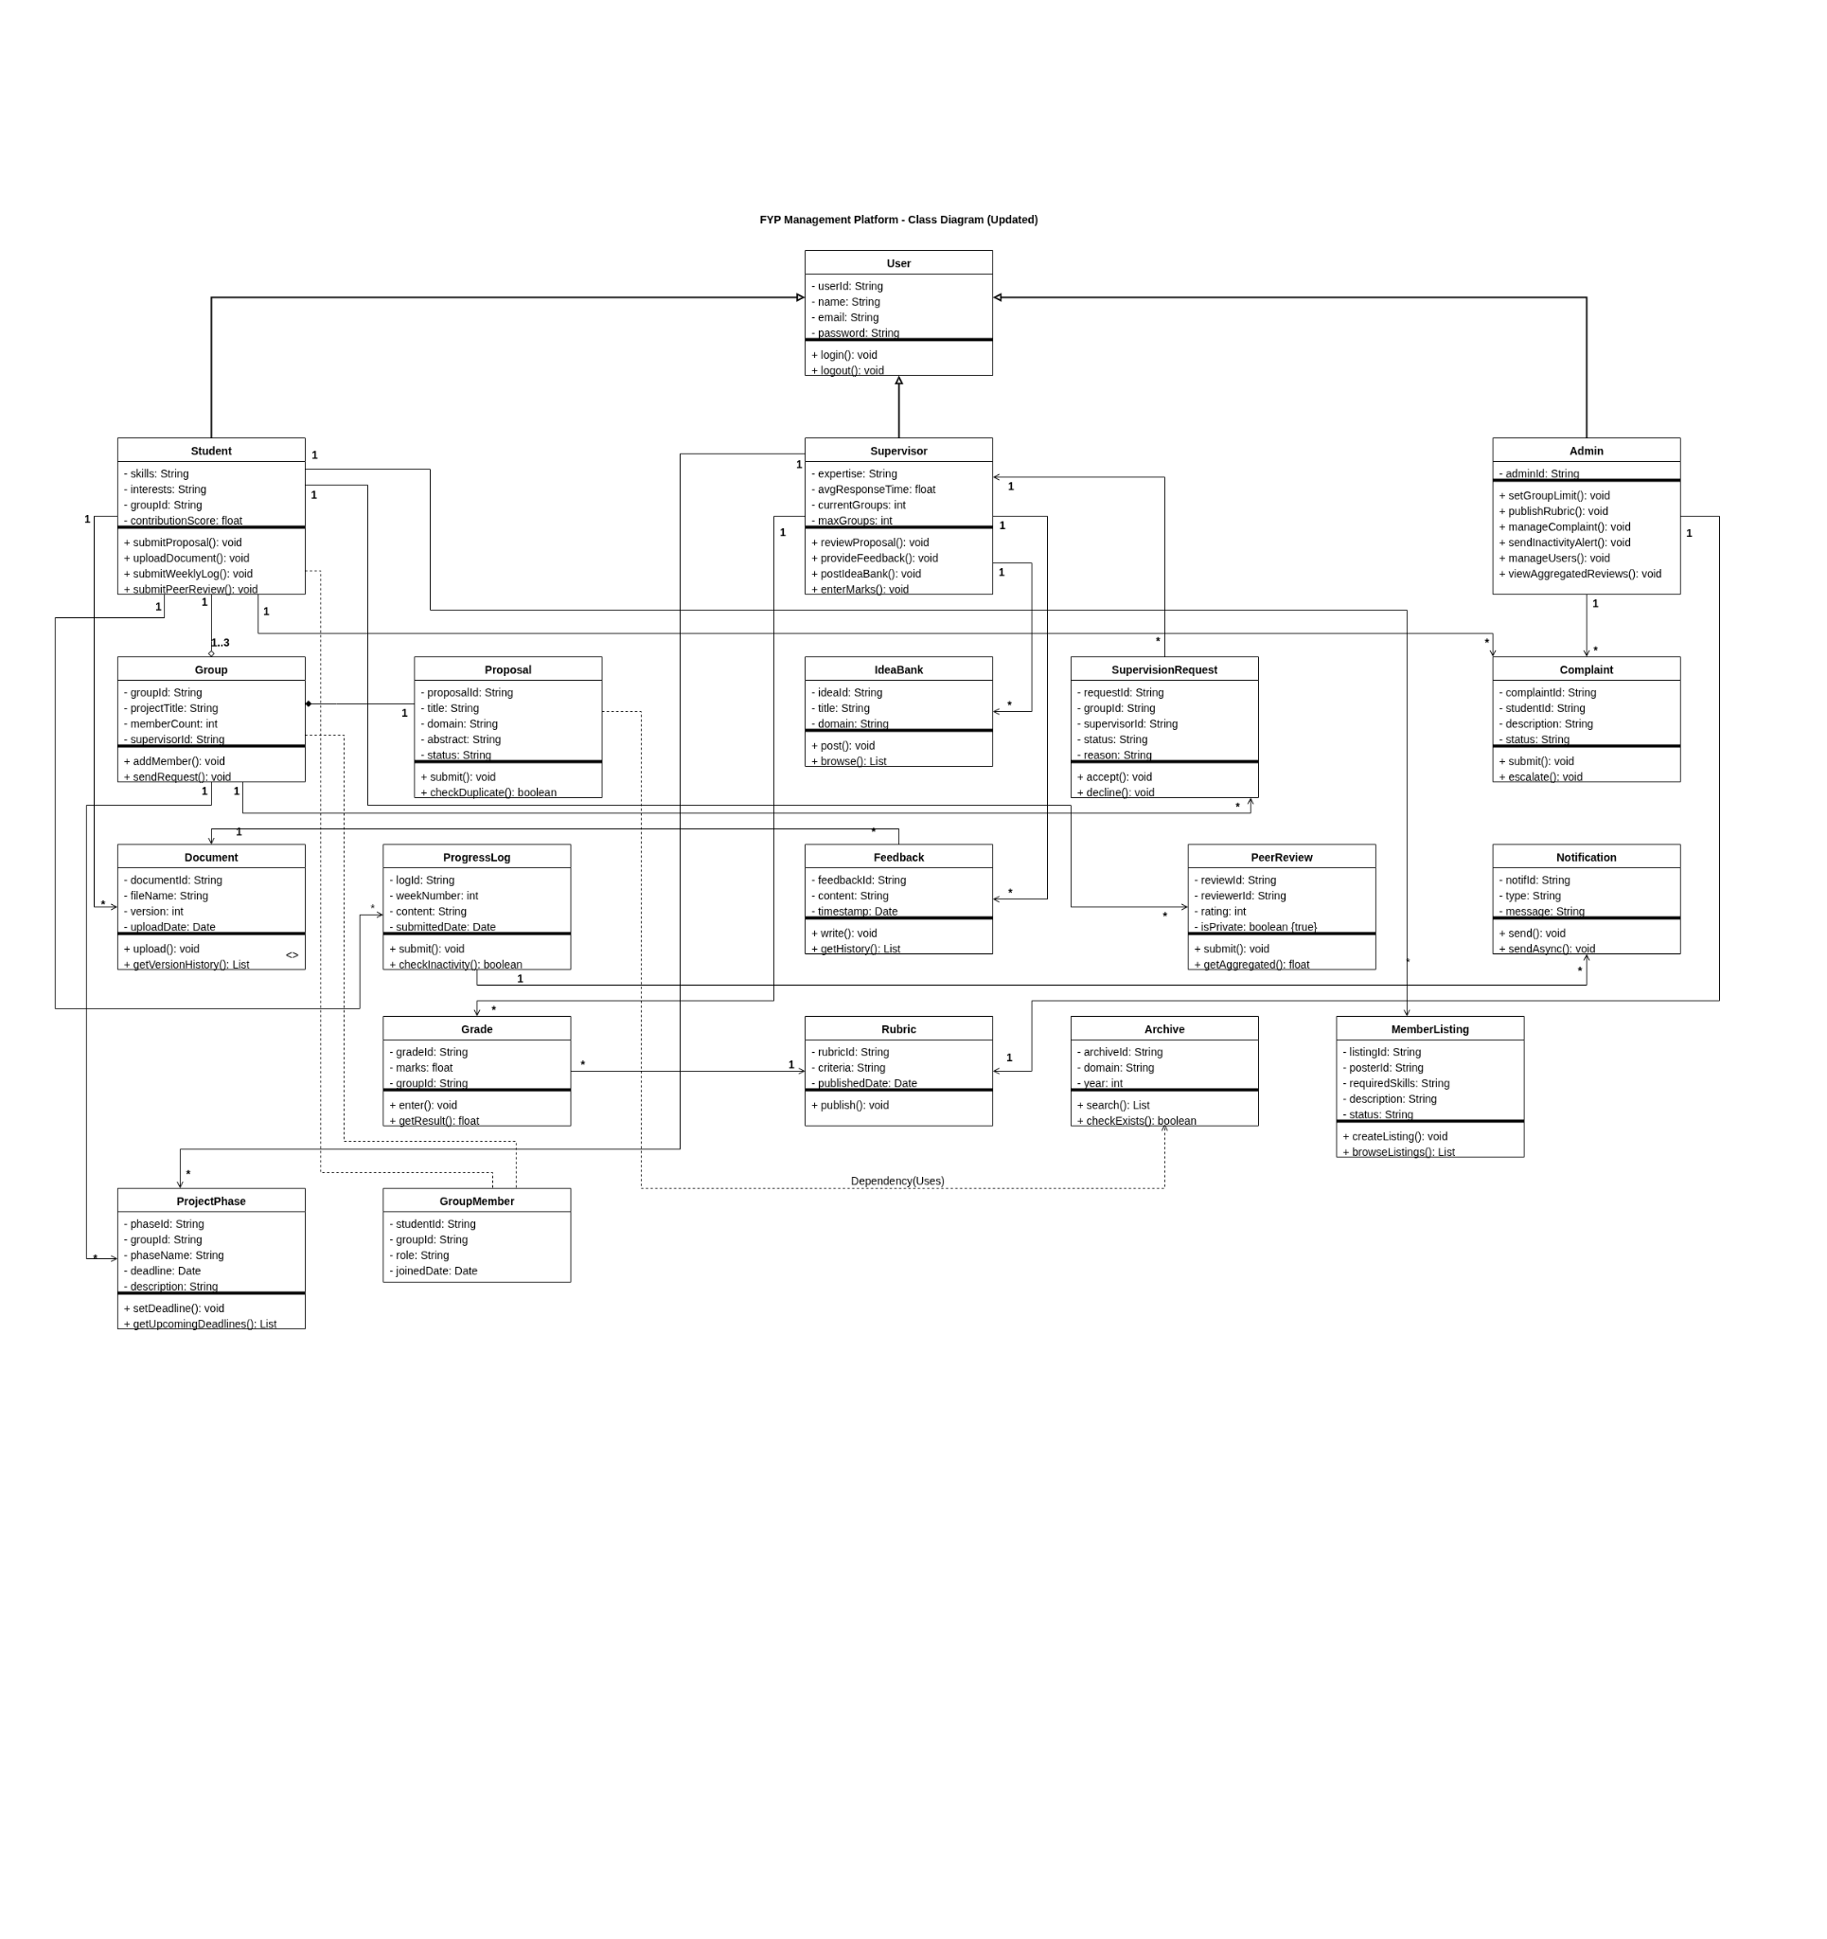Figure 2: UML Class Diagram

7. UML Sequence Diagrams:
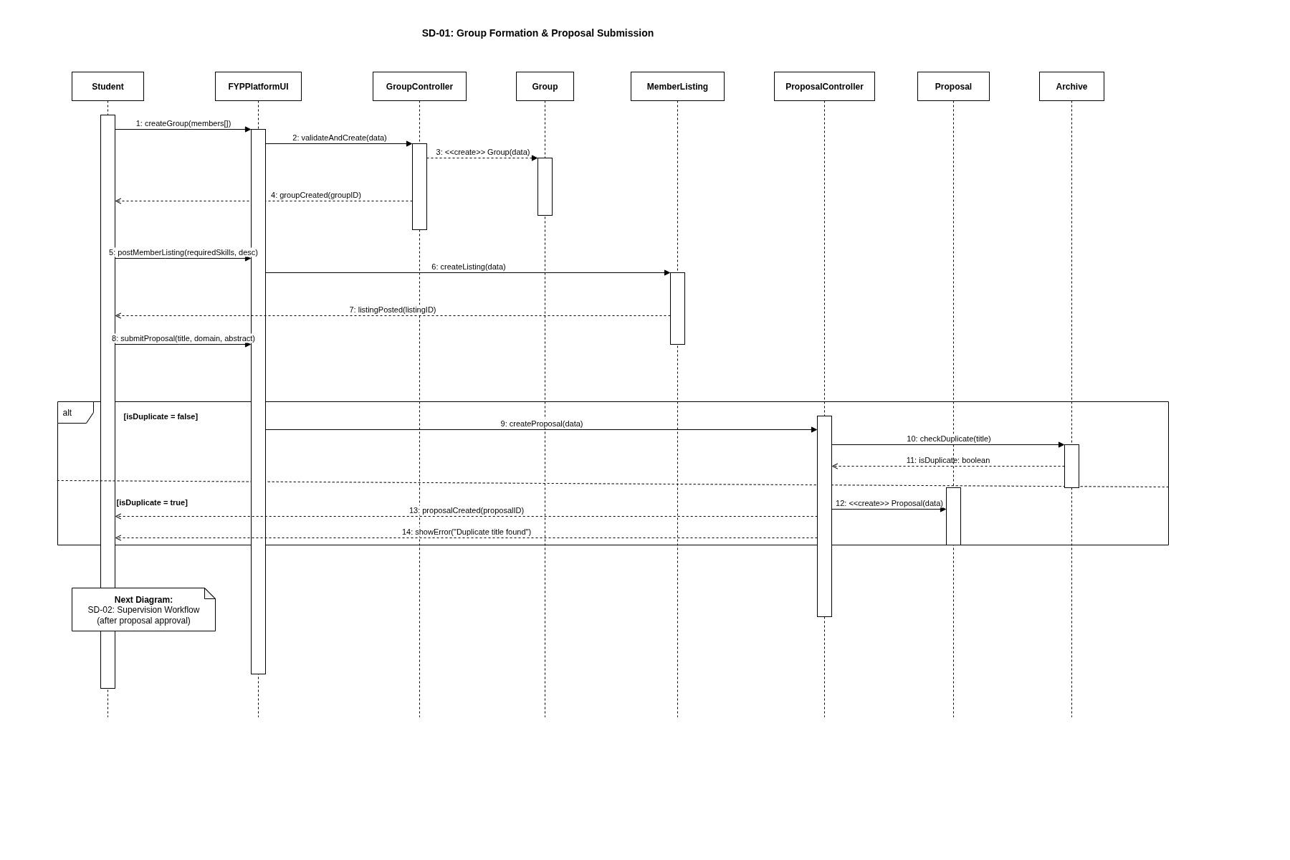
Figure 3: Sequence Diagram_1
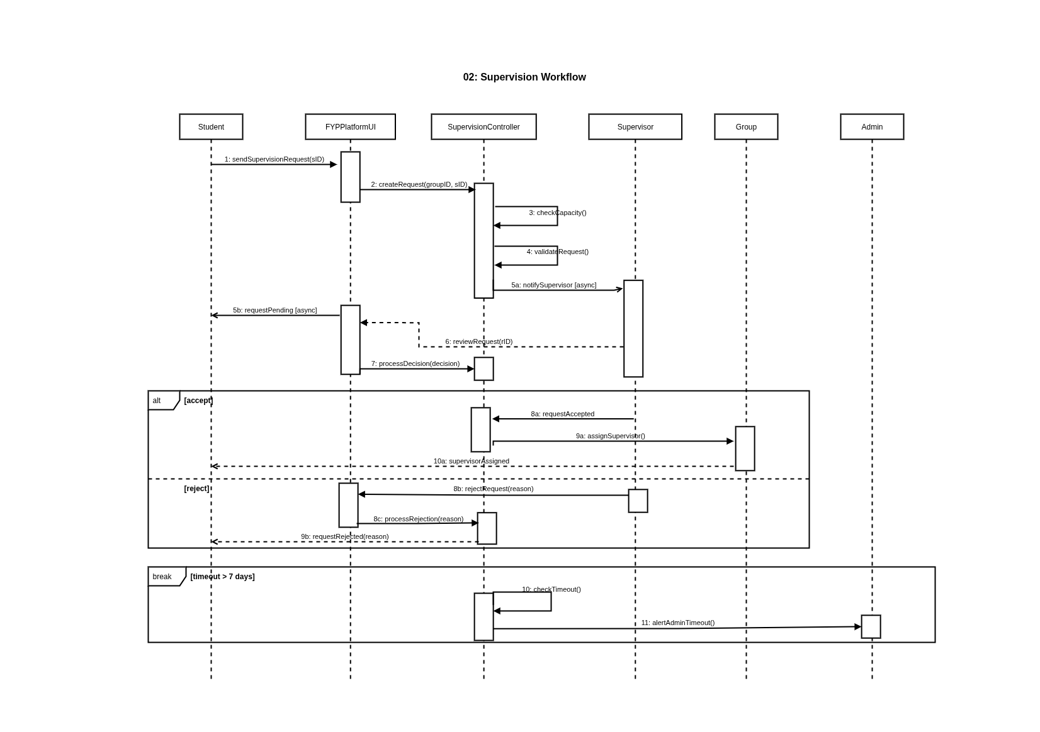
Figure 4: Sequence Diagram_2
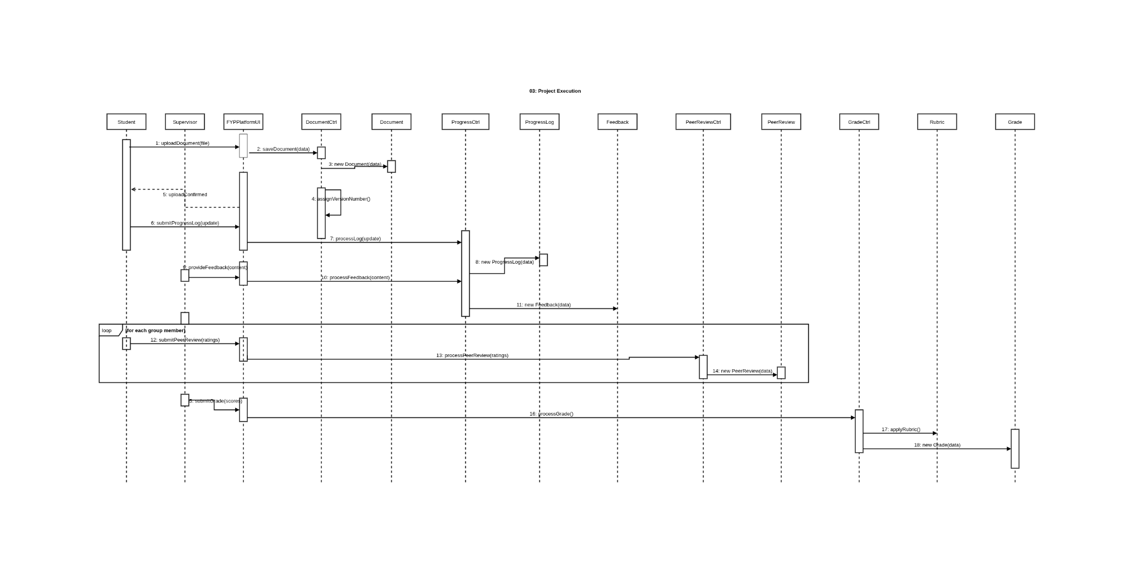
Figure 5: Sequence Diagram_3

8. UML Activity Diagrams:
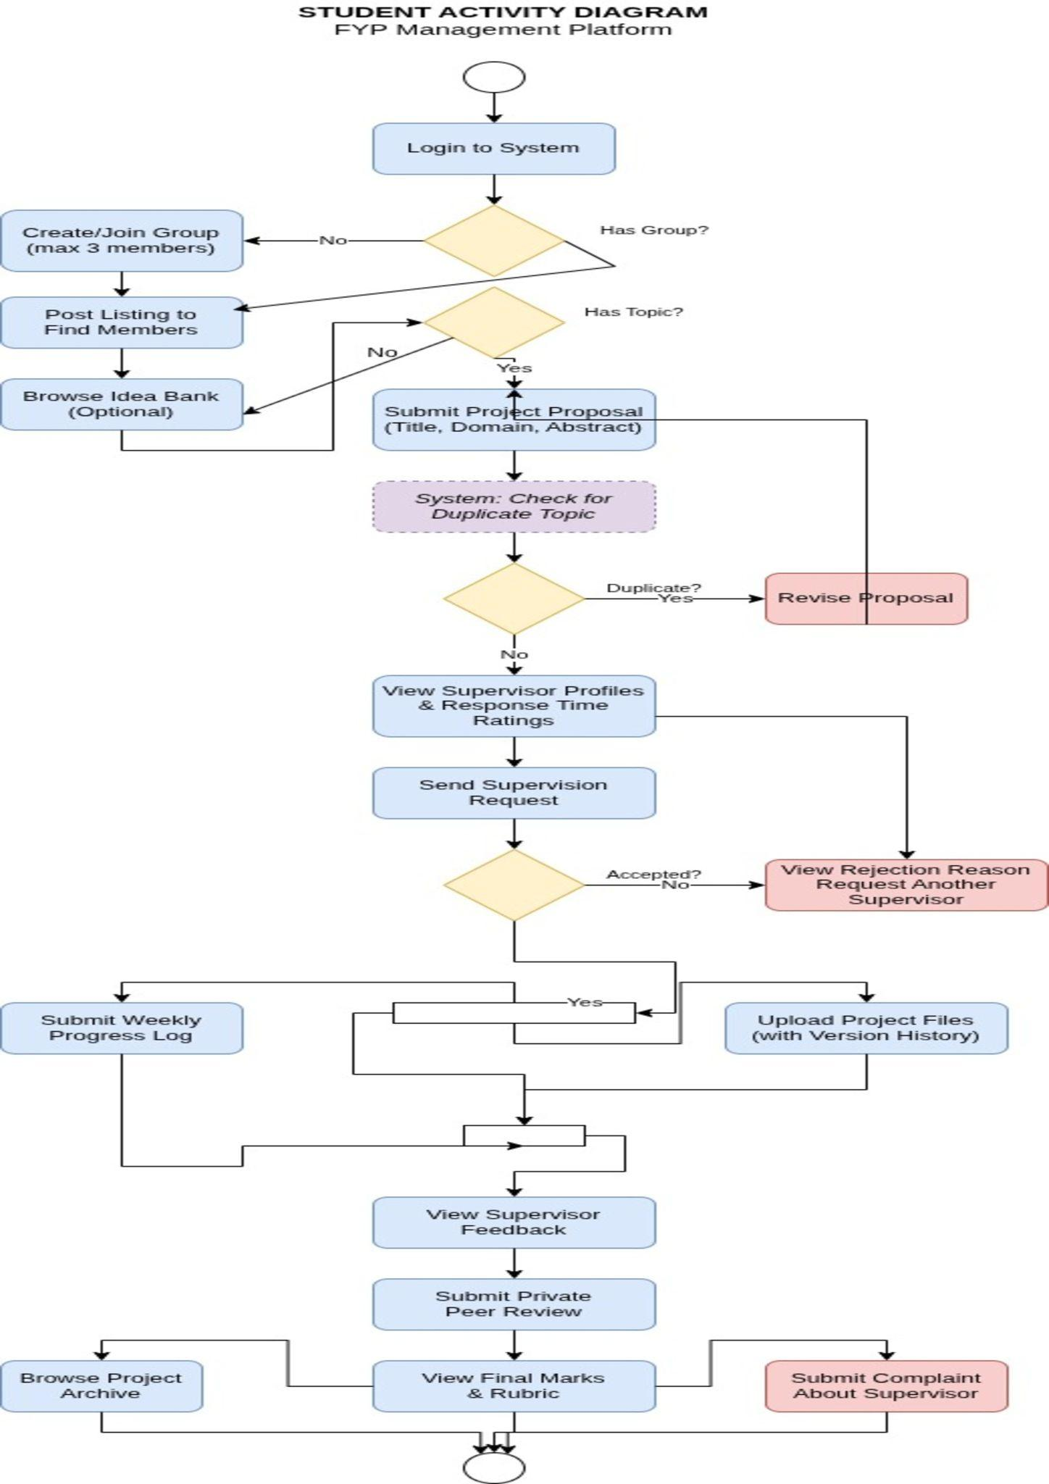
Figure 6: Student Activity Diagram

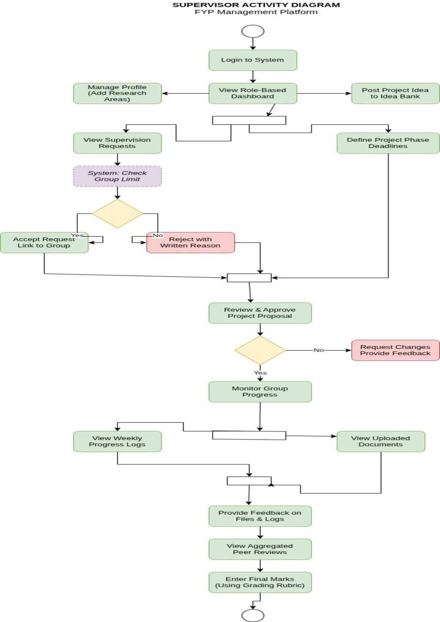
Figure 7: Supervisor Activity Diagram
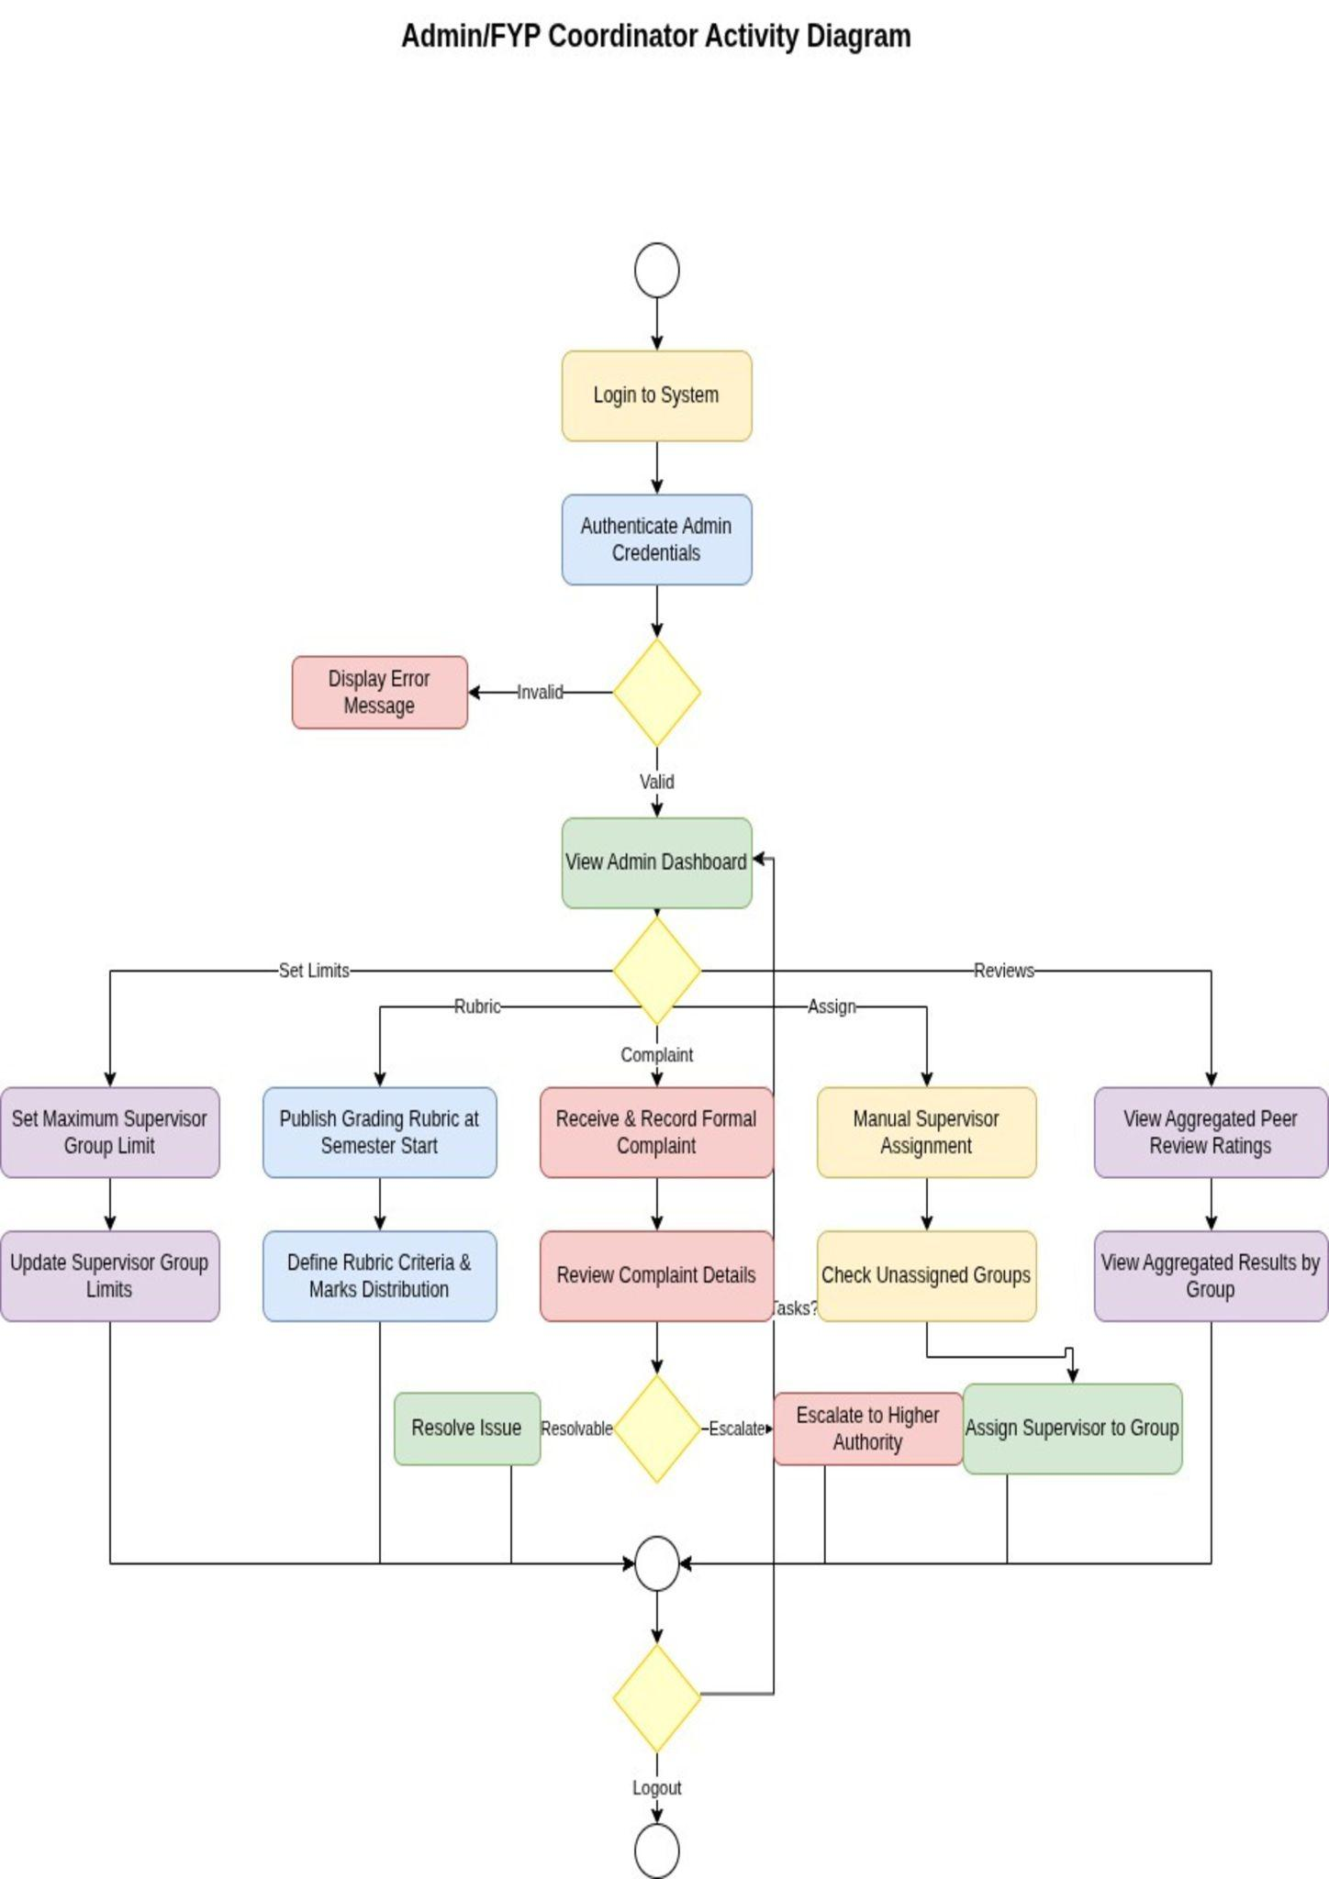
Figure 8: ADMIN Activity Diagram

9. State Machine Diagrams:
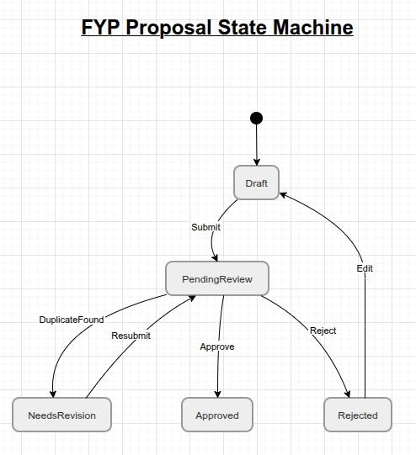

Figure 9: State Machine-1
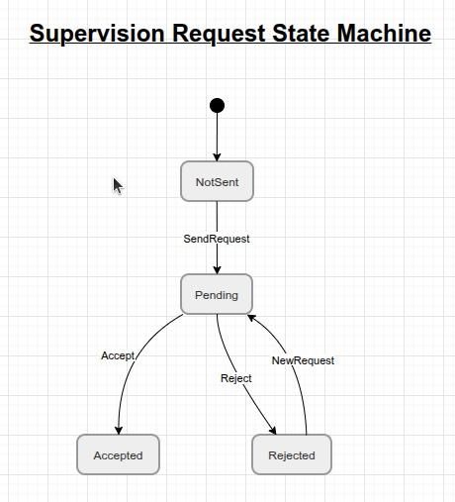

Figure 10: State Machine-2
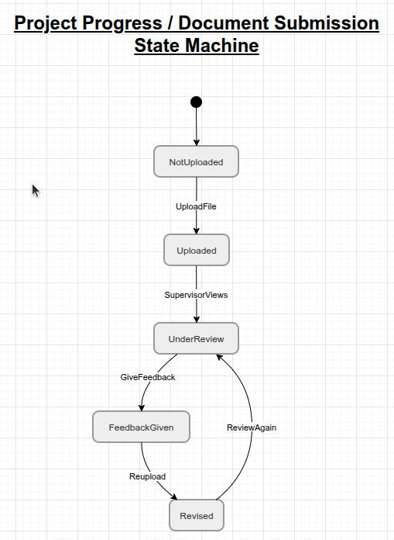

Figure 11: State Machine-3
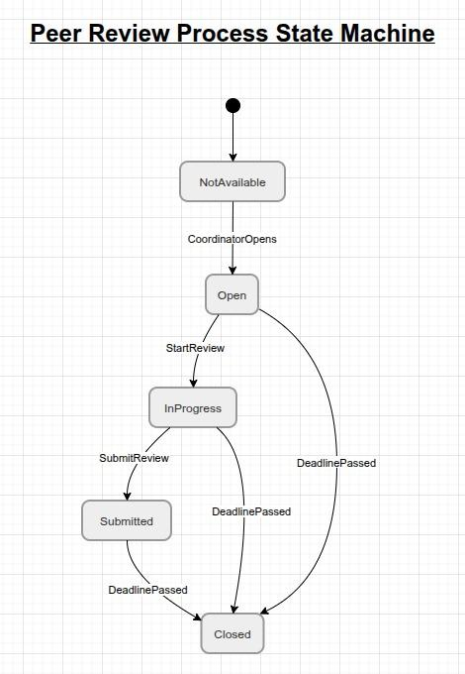

Figure 12: State Machine-4

